Here’s a clear, structured bullet-point summary of Reading 4.1: Monitoring on AWS:

🔍 What is Monitoring?
- Collecting, analyzing, and using data to assess IT resources and systems.
- Provides near real-time visibility into operational health and usage.
- Helps detect issues like over-utilization, application flaws, misconfigurations, or security events.
- Data collected = metrics (outputs of the system).

📊 Metrics and Their Use
- Metric = individual data point from a resource.
- Metrics over time = statistics (e.g., average CPU utilization).
- Example:
  - High CPU utilization → flood of requests OR faulty process consuming CPU.
  - Abnormal sustained CPU usage → trigger manual/automatic resolution (e.g., scaling).
- Other EC2 metrics: network utilization, disk performance, memory utilization, application logs.

⚙️ Types of Metrics by Resource
- EC2: CPU utilization, network traffic, disk performance, memory usage, logs.
- S3: bucket size, number of objects, request metrics (read/write).
- RDS: database connections, CPU utilization, disk space consumption.
- Different AWS resources → different relevant metrics.

🌟 Benefits of Monitoring
- Proactive issue response: Detect outages before users notice (e.g., latency, error rates).
- Performance & reliability improvement: Identify bottlenecks, optimize architecture.
- Security threat detection: Establish baselines, spot anomalies (e.g., unusual traffic/IPs).
- Business insights: Track feature usage, guide investment decisions.
- Cost optimization: Identify underutilized resources, rightsize for efficiency.

🖥️ Amazon CloudWatch
- Centralized monitoring and observability service.
- Collects metrics, logs, events, and provides unified operational view.
- Key capabilities:
  - Detect anomalous behavior.
  - Set alarms for alerts.
  - Visualize logs/metrics in AWS Console.
  - Automate actions (e.g., scaling).
  - Troubleshoot issues.
  - Discover insights to maintain application health.

Here’s a structured bullet-point summary of Reading 4.2: Introduction to Amazon CloudWatch:

⚙️ How CloudWatch Works
- Managed service — no infrastructure management required, just an AWS account.
- Centralized monitoring for multiple AWS services (e.g., EC2, S3, RDS).
- Many AWS services automatically send metrics to CloudWatch.
- Basic monitoring:
  - Free, 1 data point per metric every 5 minutes.
  - Provides visibility without extra cost.
- Detailed monitoring:
  - Higher granularity (1-minute intervals).
  - Extra fee applies (see CloudWatch Pricing).

📊 Breaking Down Metrics
- Each metric has a timestamp and belongs to a namespace (isolated categories).
- Metrics include dimensions (name/value pairs) to identify/filter data.
  - Example: Use InstanceId dimension to view stats for a specific EC2 instance.

🛠️ Custom Metrics
- Used for application-level data not posted by default (e.g., page views).
- Examples:
  - Web page load times
  - Request error rates
  - Number of processes/threads
  - Amount of work performed by the app
- High-resolution custom metrics:
  - Collect data at 1-second resolution.
  - One data point per second per metric.
- Publish custom metrics programmatically via PutMetricData API.

📈 CloudWatch Dashboards
- Visualize and review metrics in the CloudWatch console.
- Dashboards = customizable home pages with widgets (graphs, text, etc.).
- Can build multiple dashboards for different views.
- Support cross-Region data → global architecture view.
- Metrics aggregated by chosen time period; option to display live data (last minute, not fully aggregated).
- External/custom tools can ingest CloudWatch metrics via GetMetricData API.

🔐 Security for Dashboards
- Access controlled via AWS IAM policies.
- Policies can be applied to IAM users, groups, or roles.
- Ensures only authorized individuals can view/manage dashboards.

Here’s a clear, structured bullet-point summary of CloudWatch Logs and Alarms:

📂 CloudWatch Logs Overview
- Centralized place to store, monitor, and analyze logs.
- Supports logs from:
  - Applications on EC2 instances
  - AWS Lambda functions
  - Other AWS services and custom sources
- Enables querying and filtering log data (e.g., searching for stack traces).
- Metric filters: Convert log data into numerical metrics for dashboards and alarms.

⚙️ Sending Logs to CloudWatch
- AWS Lambda: Minimal setup, just IAM permissions to post logs.
- EC2 instances: Requires installing and configuring the CloudWatch Logs agent.
  - Agent components:
    - CLI plug-in to push log data
    - Script to initiate log push
    - Cron job to keep daemon running

📖 CloudWatch Logs Terminology
- Log event: Single record of activity (timestamp + message).
- Log stream: Sequence of log events from the same resource (e.g., one EC2 instance).
- Log group: Collection of log streams with shared retention and permissions (e.g., multiple EC2 instances grouped together).

🚨 CloudWatch Alarms
- Automate actions based on sustained metric state changes.
- Steps to configure:
  - Choose metric (e.g., CPU utilization).
  - Define threshold (e.g., >80%).
  - Specify time period (e.g., sustained for 5 minutes).
- Alarm states:
  - OK: Metric within threshold.
  - ALARM: Metric outside threshold.
  - INSUFFICIENT_DATA: Not enough data or alarm just started.
- Actions triggered by alarms:
  - EC2 actions (e.g., reboot instance).
  - Auto Scaling actions.
  - Notifications via Amazon SNS.

🛡️ Using Alarms to Prevent & Troubleshoot Issues
- Example:
  - Metric filter for 500-error responses.
  - Alarm triggers if >5 errors/hour.
  - Action: Send SNS notification (email/text) for manual troubleshooting.
- Alarms can also trigger automated remediation:
  - EC2 reboot or scaling.
  - SNS → Lambda → AWS API calls for resource management.
- Enables faster response to operational issues.

Here’s a structured bullet-point summary of Reading 4.3: Optimizing Solutions on AWS:

📈 What Is Availability?
- Availability = percentage of uptime in a year, expressed as “number of nines.”
- Common availability levels:
  - 90% (one nine) → 36.53 days downtime/year
  - 99% (two nines) → 3.65 days downtime/year
  - 99.9% (three nines) → 8.77 hours downtime/year
  - 99.95% (three and a half nines) → 4.38 hours downtime/year
  - 99.99% (four nines) → 52.60 minutes downtime/year
  - 99.995% (four and a half nines) → 26.30 minutes downtime/year
  - 99.999% (five nines) → 5.26 minutes downtime/year
- Higher availability requires redundancy (extra servers, data centers, replication).
- Trade-off: More redundancy → higher cost, so balance against revenue.

⚙️ Improve Application Availability
- Current setup:
  - One EC2 instance (single point of failure).
  - Photos in Amazon S3 (highly available).
  - Structured data in Amazon DynamoDB (highly available).
- Problem: If EC2 instance fails, customers cannot connect.
- Solution: Add another EC2 instance → removes single point of failure.

🌍 Use a Second Availability Zone
- Physical location matters: failures can occur at server, rack, data center, or AZ level.
- Deploying EC2 instances across multiple Availability Zones increases resilience.
- Helps mitigate OS, application, and hardware-level issues.

🔄 Manage Replication, Redirection, and High Availability
- Replication:
  - Need to replicate configuration files, patches, and application across instances.
  - Best practice → automate replication.
- Redirection:
  - DNS can point clients to multiple servers, but suffers from propagation delays.
  - Load balancer preferred → performs health checks, distributes traffic, avoids propagation issues.
- Types of High Availability:
  - Active-Passive:
    - Only one instance active at a time.
    - Good for stateful applications (session data tied to one server).
  - Active-Active:
    - Both instances active simultaneously.
    - Provides scalability and better load distribution.
    - Works best for stateless applications (no session dependency).

Here’s a structured bullet-point summary of Reading 4.4: Route Traffic with Amazon Elastic Load Balancing (ELB):

⚖️ What’s a Load Balancer?
- Distributes tasks (requests) across multiple resources (e.g., EC2 instances).
- Ensures no single server is overloaded.
- Common algorithm: Round-robin (requests sent sequentially to servers).
- Traffic flow: Client → Load Balancer → EC2 instance → Load Balancer → Client.
- AWS provides Elastic Load Balancing (ELB) as a managed service (no need to install/manage software).

🌟 Features of ELB
- Distributes traffic across EC2, containers, IP addresses, and Lambda functions.
- Supports hybrid mode (can balance to on-premises servers via IPs).
- Highly available when deployed across multiple Availability Zones.
- Automatically scales to meet traffic demand.

🩺 Health Checks
- Critical to define meaningful health checks (not just port open or homepage call).
- Example: Custom /monitor page that checks DB connectivity and S3 access.
- ELB only routes traffic to healthy instances.
- Integrates with EC2 Auto Scaling:
  - Removes unhealthy instances and replaces them.
  - Supports connection draining (waits for existing connections to finish before terminating).

🔧 ELB Components
- Listeners: Client-side entry point (port + protocol).
- Target groups: Backend resources (EC2, Lambda, IPs) + health checks.
- Rules: Conditions (e.g., source IP, path) that map listeners to target groups.

🌐 Application Load Balancer (ALB)
- Routes traffic based on HTTP/HTTPS request data (path, host, headers, method, query string).
- Can send fixed responses or redirects (e.g., HTTP → HTTPS).
- Supports TLS offloading (SSL certificates via IAM or ACM).
- Provides user authentication (OpenID Connect, SAML, LDAP, Microsoft AD).
- Secures traffic via security groups.
- Routing algorithms:
  - Round-robin (default).
  - Least outstanding requests (better for uneven workloads or varied instance sizes).
- Supports sticky sessions (HTTP cookies for stateful apps).
- Best for HTTP/HTTPS traffic.

⚡ Network Load Balancer (NLB)
- Supports TCP, UDP, TLS protocols (connection layer).
- Routing algorithm: Flow hash (protocol, IPs, ports, TCP sequence).
- Sticky sessions based on source IP address.
- Supports TLS offloading.
- Handles millions of requests per second instantly.
- Supports static and elastic IP addresses (useful for firewall rules or DNS limitations).
- Preserves client source IP address (important for backend apps needing real IP).
- Best for non-HTTP protocols or ultra-high performance needs.

🔍 Selecting Between ALB vs NLB
- ALB:
  - HTTP/HTTPS protocols.
  - Advanced routing (path, host, headers).
  - Redirects, fixed responses.
  - User authentication.
- NLB:
  - TCP/UDP/TLS protocols.
  - Static/elastic IP support.
  - Preserves source IP.
  - Instant scaling for millions of requests.

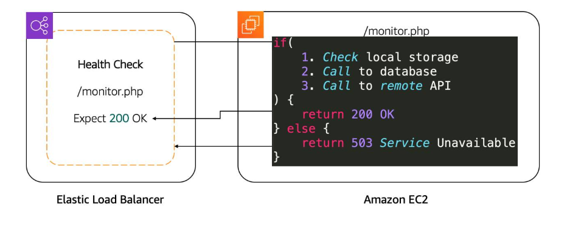
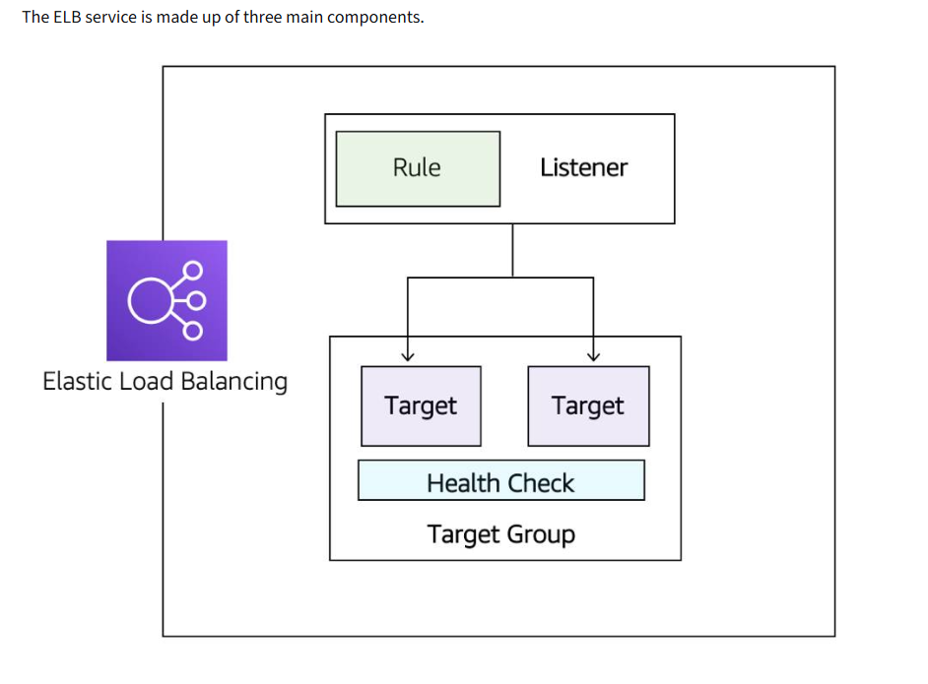
Feature | Application Load Balancer | Network Load Balancer
Protocols | HTTP, HTTPS | TCP, UDP, TLS
Connection draining (deregistration delay) | ✔
IP addresses as targets | ✔ | ✔
Static IP and Elastic IP address |  | ✔
Preserve Source IP address |  | ✔
Routing based on Source IP address, path, host, HTTP headers, HTTP method, and query string | ✔
Redirects | ✔
Fixed response | ✔
User authentication | ✔

Here’s a structured bullet-point summary of Reading 4.5: Amazon EC2 Auto Scaling:

📈 Vertical Scaling (Active-Passive Systems)
- Active server can become overloaded → failover to passive server doesn’t solve capacity issues.
- Vertical scaling = increase server size/type (larger EC2 instance).
- Steps:
  - Stop passive instance.
  - Change instance size/type.
  - Start passive instance → make it active.
  - Repeat for previous active instance.
- Limitations:
  - Manual, repetitive work.
  - Scaling limited by maximum instance size.
  - May require rewriting applications if limits are reached.

🌐 Horizontal Scaling (Active-Active Systems)
- Stateless applications (no client session stored on server) enable horizontal scaling.
- Add/remove EC2 instances as traffic changes → no app changes required.
- Amazon EC2 Auto Scaling automates this process:
  - Creates/removes EC2 instances based on CloudWatch metrics.
  - Provides flexibility, scalability, and efficiency.

🔗 Integrating ELB with EC2 Auto Scaling
- ELB notified when new EC2 instances are added/removed.
- ELB validates instance health before routing traffic.
- Health check types:
  - TCP connection check (backend reachable).
  - HTTP/HTTPS request check (valid response code).
- Ensures only healthy instances receive traffic.

⚖️ Traditional Scaling vs Auto Scaling
- Traditional scaling:
  - Provision servers for peak traffic.
  - Leads to over-provisioning (wasted cost) or under-provisioning (lost customers).
  - Turning off servers saves electricity but not cloud costs.
- Auto Scaling:
  - Pay-as-you-go model.
  - Automatically adjusts capacity based on conditions.
  - Prevents waste and ensures availability during traffic spikes.

🚀 Benefits of Amazon EC2 Auto Scaling
- Maintains steady, predictable performance at lowest cost.
- Adjusts capacity to match application usage → pay only for what’s needed.
- Provides fleet management:
  - Automatically replaces unhealthy EC2 instances.
  - Ensures high availability and resilience.

⚙️ EC2 Auto Scaling Components
- Launch template/configuration → defines resources to scale.
- Auto Scaling Group → defines where resources are deployed.
- Scaling policies → define conditions for adding/removing resources.

Here’s a structured bullet-point summary of Launch Templates, Auto Scaling Groups, and Scaling Policies:

📑 Launch Templates
- Store all parameters needed to create EC2 instances:
  - AMI ID, instance type, security group, EBS volumes, key pair, tags, etc.
- Used by EC2 Auto Scaling to launch instances automatically.
- Can also be used to manually launch EC2 instances.
- Support versioning:
  - Roll back quickly if issues occur.
  - Specify a default version for stability while iterating.
- Ways to create a launch template:
  - From an existing EC2 instance (fastest).
  - From an existing template or previous version.
  - From scratch (define AMI, type, security, storage, tags).
- Launch configurations (older method):
  - Similar but lack versioning and flexibility.
  - Best practice → use launch templates instead.

🖇️ EC2 Auto Scaling Groups (ASG)
- Define where EC2 Auto Scaling deploys resources:
  - Specify VPC and subnets (at least two across different AZs for high availability).
- Support purchase options:
  - On-Demand, Spot, or combination (cost optimization).
- Capacity settings:
  - Minimum: Lowest number of instances always running.
  - Maximum: Upper limit to control costs.
  - Desired capacity: Target number of instances; Auto Scaling adjusts to match.
- Behavior:
  - Scales down until minimum is reached.
  - Scales up until maximum is reached.
  - Removes oldest instance when decreasing; creates new ones using launch template when increasing.
- Fleet management:
  - If min = max = desired (e.g., 4), Auto Scaling ensures that number is always maintained by replacing unhealthy instances.

⚙️ Scaling Policies
- Automate changes to desired capacity based on CloudWatch metrics and alarms.
- Types:
  - Simple Scaling Policy
    - Triggered by a single CloudWatch alarm.
    - Adds/removes instances or sets desired capacity.
    - Includes cooldown period to avoid rapid scaling.
    - Limitation: Cannot handle multiple thresholds (e.g., 70%, 85%, 95%).
  - Step Scaling Policy
    - Responds to multiple thresholds with different actions.
    - Example: +2 instances at 85% CPU, +4 at 95%.
    - More flexible than simple scaling.
  - Target Tracking Scaling Policy
    - Automatically adjusts capacity to maintain a target metric (e.g., average CPU utilization, network I/O, request count).
    - Simplifies scaling by auto-creating CloudWatch alarms.
    - Recommended for most dynamic workloads.

